Abstract:

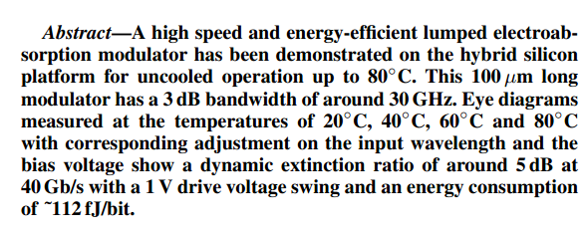

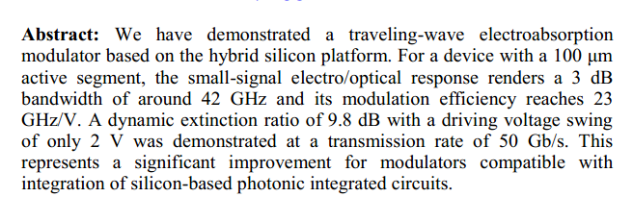

APL:

Graphene, a well-known two-dimensional (2D) sheet, has attracted strong interest for both fundamental studies and applications. Due to its high intrinsic thermal conductivity, graphene has many potential applications in thermal management, such as in heat spreaders, flexible heaters, etc. In this paper, a graphene-based transparent flexible heat conductor for nanophotonic integrated devices is demonstrated for the first time. The graphene heat conductor is designed to deliver heat from a non-local traditional metal heater to nanophotonic integrated devices for realizing efficient thermal tuning. With the present graphene heat conductor, a thermally tuning silicon Mach-Zehnder interferometer (MZI) and micro-disk have been realized with good performance in terms of heating efficiency and temporal response. This indicates that the present graphene-based transparent flexible heat conductor provides a novel, efficient and beneficial heating method for thermally tuning nanophotonic integrated devices.

APL:

Electroabsorption in highly strained GaInAs and GaInNAs quantum wells QWs grown on GaInAs or quasi-GaInAs substrates is investigated by using microscopic many-body theory. The effects of various parameters, such as strain, barrier height, substrate composition, and temperature are thoroughly examined. It is shown that the value of the absorption coefficient strongly depends on the depth of the QWs under large bias electric field due to the small overlap integral of wave functions between the conduction and valence bands. The use of GaInNAs QWs makes the strain in the well layer very small. Further, the effective quantum-well depth is increased in GaInNAs QWs due to the anticrossing interaction between the conduction and N-resonant bands, making it possible to obtain larger absorption coefficient under large bias electric fields without using wide-band gap materials for barriers.

APL:

We have demonstrated efficient intersubband electroabsorption in InGaAs/InAlGaAs/InAlAs step quantum wells grown by metal-organic vapor-phase epitaxy. An absorption modulation of 6 dB (Δα = 2300 cm−1) at λ ~5.7μm due to Stark shift of the intersubband resonance was achieved at a low applied voltage swing of ± 0.5 V in a multipass waveguide structure. The interface intermixing was estimated by comparing experimental and theoretical Stark shifts. It is predicted that the present material in a strongly confining surface plasmon waveguide can yield an electroabsorption modulator with a peak-to-peak voltage of Vpp = 0.9 V and modulation speed of f3dB ≈ 130 GHz.

APL:

We report on slow-light GaInAs/GaAs electro-absorption modulators with a Bragg reflector waveguide. We fabricated 20 ~100 μm long compact modulators composed of triple GaInAs/GaAs quantum wells sandwiched by highly reflective Bragg reflectors.

A large group index of 20 enables us to reduce the size of the modulators. We demonstrated 6 dB intensity modulation with a voltage swing Vpp below 0.5 V for 50 μm long devices.

Shorter devices, for example with a length of only 20 μm, also showed an extinction ratio over 4 dB for sub-volt driving. Characterizations on wavelength dependence were also carried out experimentally.

Myself:

A new way to make low voltage driven electroabsorption modulator based on band filling effect is demonstrated. The electroabsorption modulator composed of InAlGaAs quantum wells is integrated on silicon-on-insulator wafer. The band filling effect is achieved by making electroabsorption modulator working at forward bias. In this way, the exciton absorption blue shifts and the absorption peak also keeps same. We fabricated 80 μm long compact electroabsorption modulator. In static transmission performance, we can achieve extinction ratio more than 20dB with only 100mV variation. For high speed transmission performance, we show a 1.25Gbps electroabsorption modulator, with only 50mV peak-peak drive voltage and the extinction ratio is 6.3dB. This indicates that the present band-filling effect in electroabsorption modulator provides a novel method for low driven voltage optical modulator.

Paper2

**The large concentrations of free carriers (electrons or holes) present in modulation-doped quantum well (MDQW) samples have important effects on their optical properties. We discuss here the temperature-dependent optical absorption and luminescence spectra of GaAsj AIGaAs and InGaAsjlnAlAs n-doped MDQW's with emphasis on the peak seen at the edge of the absorption spectra of these samples. We present here a many-body calculation of the electron-hole corre-lation enhancement , which identifies this peak with the Mahan exci-ton-the result of the Coulomb interaction between the photoexcited hole in the valence band and the sea of electrons in the conduction band. This calculation accounts for the strong dependence of the ab-sorption edge peak on both the temperature and the carrier concentra-tion , in good qualitative agreement with our data and with previously published results. We also analyze the changes induced by the carriers on the subband structure through self-consistent calculations , and we conclude that in these symmetric structures , the changes are small for achievable carrier densities.**

Previous:

We show GHz modulation in a 80μm long electroabsorption modulator, with only 50mV peak-peak drive voltage and high extinction ratio. The low-driven-voltage electroabsorption modulator is the first modulator based on band filling effect, which present a new approach for high speed low driven voltage modulators.

OE

We show GHz modulation in a 2.5 µ m radius silicon micro-ring, with only 150 mV peak-peak drive voltage and an electro-optic modal volume of only 2 µ m3. The swing voltage and the micro-ring modulator are the smallest demonstrations so-far in silicon. The presented approach lays the ground work for a new class of high speed low voltage modulators enabling, seamless integration of nanophotonics with low voltage digital CMOS nano-electronics